Integrator

Microsoft Dynamics CRM add-in guide

# Contents

Contents 2

Introduction 3

Configuration 4

Testing 5

Dialling configuration 6

# 

# Introduction

Microsoft Dynamics CRM 3, 4 & 2011 Add-in Guide

This document will guide you through configuration and basic use of Horizon Integrator’s Microsoft Dynamics CRM Add-in. It is expected that you are already familiar with the Address Book, Call History and Preview window, and the basic concepts of integration and screen popping using the Add-in. See the full user guide for these topics.

Microsoft Dynamics CRM and the database used to store your contact data should already be installed and working normally before proceeding with this integration.

Integrator must also be installed already with the initial configuration completed. If this is not the case, please see the full user guide or consult your Horizon administrator.

# 

# Configuration

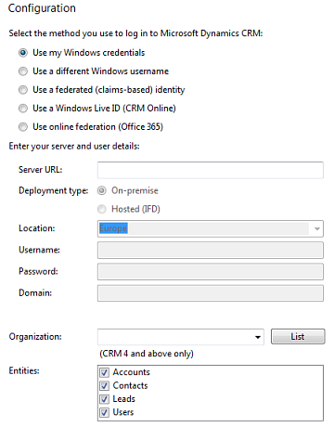Right-click the tray icon in the system tray menu and then left-click the ‘Configuration’ option from the menu that pops up. In the ‘Integration’ area, click the ‘(Add new)’ button, select ‘Microsoft Dynamics CRM’ from the ‘Type’ dropdown box and then click the ‘Set’ button.

First select the method you use to log in to Microsoft Dynamics CRM

On the “Deployment type”, select which type of Microsoft Dynamics CRM you use:

If you choose (CRM Online) for log in enter your Windows Live ID information, including which of Microsoft’s server groups you log on to (Europe, Asia-Pacific, or Americas).

If your Microsoft Dynamics CRM server is available on your LAN, select ‘On-premise’, or select ‘Hosted (IFD)’ if it is over the Internet but not via Microsoft CRM Online. For either case, in the ‘Server URL’ text box, you need to enter the web address you visit to access Dynamics CRM e.g. http://mscrm/. You’ll find this info in Internet Explorer’s address bar when you login to Dynamics.

Under the ‘Server URL’ box, select which type of authentication to use. Most users will be able to use the ‘Use Windows credentials’ option. If you are prompted for username and password when loading Dynamics CRM in your browser, uncheck ‘Use Windows credentials’ and enter the relevant details in the ‘Username’, ‘Password’ and ‘Domain’ textboxes below it.

For those of you using version 4 or above of Dynamics CRM, your organization needs to be selected also. After entering all of the details above, click ‘List’ and all the organizations that your user has access to will be listed in the ‘Organization’ box. Usually your user will only have access to one organization.

Select which of your Dynamics account modules you want to be used by ticking the corresponding boxes in the ‘Entities’ section.

# Testing

To test if the configuration worked, enter a phone number from your Dynamics account into the ‘Telephone’ box in the ‘Integration test’ area and click the ‘Search’ button. The results will be displayed after a few seconds.

If the test does not work, go to the ‘Log’ page of configuration and turn on logging, then do the test again and see if there are any errors in the log.

# 

# Dialling configuration

To dial out from within Dynamics, dialling needs to be configured correctly.

Right-click the tray icon in the system tray menu and then left-click the ‘Configuration’ option from the menu that pops up, this will open the ‘Configuration’ screen. In the ‘General’ group, click on the ‘Dialling’ option.

Make sure the ‘Web page dialling’ box is ticked. This converts the telephone numbers identified on web pages into hyperlinks you can click to dial the number.

You can refine the criteria used to identify telephone numbers. Enter the appropriate number of digits into the ‘Minimum length’ and ‘Maximum length’ text boxes and specify a prefix that identifies telephone numbers (if there is one) by entering it in the ‘Must start with’ box.

If you would like to be able to dial directly when you are entering new information in Dynamics e.g. on the edit contact details page, we need to carry out some further configuration so click the ‘Add’ button to start the Dialling wizard.



The first question in the wizard asks you about the type of application you want to dial from. Select the ‘The application runs inside a web browser’ option.

Click the ‘Next’ button.



We’ve already covered converting identified numbers into hyperlinks so select the ‘Text boxes’ option on the second screen of the wizard and click the ‘Next’ button.

Open your Dynamics account in Internet Explorer and find the text box you want to dial out from, it needs to have a number in it already so add one temporarily if necessary. Copy or make a note of the telephone number in the text box and leave the web page open.

Back in the wizard, paste or type the number into the ‘Number to search for’ box and click the ‘Detect’ button.



The wizard recognises that you are setting up dialling with Dynamics (a.k.a. ‘MSCRM’) and asks you if you would like to use the default settings for it. These are fine for most users so click ‘Yes’.



If you want to dial from a text box not included in the default settings, you will need to add it manually. Follow the instructions above starting with clicking the ‘Add’ button again and working through as before but click ‘No’ if asked whether you want to setup default settings.

The wizard will search the current web page for the telephone number you entered and, once found, display the details. Click ‘Next’ and then ‘Close’. You can add as many textboxes as you like, just start the process by clicking the ‘Add’ button and working your way through again.

Click ‘Save’ to store your settings and you’re ready to go. Now, a clickable icon is placed at the end of any textboxes you have configured and you just click on it to dial the number in the textbox. Refresh the page in Dynam