Horizon Integrator
  - Full user guide

Contents
Contents 2
Getting started 3
Installation 3
Signing in 3
Introduction 4
The basics 5
Tray menu 5
Phone window 6
Preview window 6
Making calls 7
Call control 8
Active call 8
Ringing call 9
Features 10
Set forward all 10
Set do not disturb 10
Presence 11
Settings and configuration 12
Telephony settings 12
12
Interface settings 12
Dialling settings 13
Events settings 13
Integration settings 14

Getting started

Installation

Your Administrator will provide you with the installer in the form of an .exe file. They may opt to install this on your behalf if administration permissions are enforced on your PC. To install;
- Double-click the installer executable and follow the installation instructions
- Launch the Integrator application

Signing in

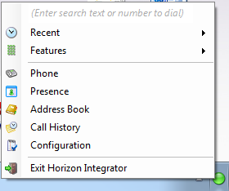
To get up and running with Integrator you'll need to enter your username and password - please note these are different than the Portal login details. Please speak to your Administrator if you don't have your log in details.

The details can be entered by right clicking the Integrator icon in your taskbar and selecting 'Configuration'.

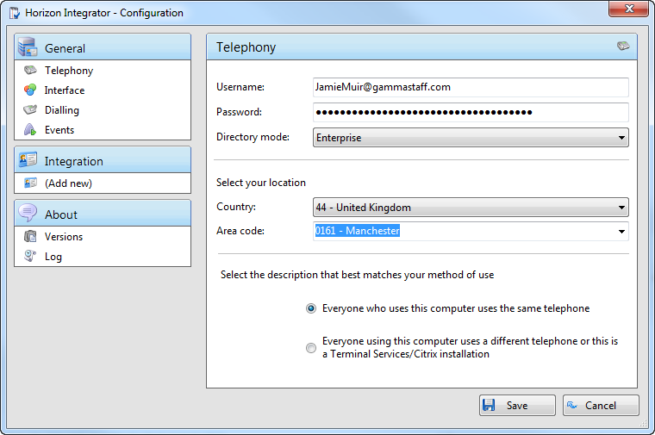
From there select 'Telephony' and enter your username and password. The directory mode will default to group, we'll touch on this later in the 'Presence' section.
You'll also need to specify your location, select your country and area code from the drop down list and click 'Save' - you should now be ready to go.

Introduction

Horizon Integrator has been designed to make your phone easier and more convenient to use. It can do this in a number of ways and this document will show you how.
Integrator is designed to be discrete. Always running and providing useful information as you need it, yet at the same time not annoying and interfering when you’re trying to work. So, most of the time, Integrator sits silently in your tray menu, waiting for you to click on it.
Note: In Windows 7, some tray icons become hidden and expressly have to be shown. These settings are stored in the ‘Notification Area Icons’ part of the Windows Control Panel and will need to be updated locally.

The basics

Tray menu

Right click on the Horizon integrator icon in your notification area. If you're sitting in available it'll be a green circle, if you're on a call it will be red.
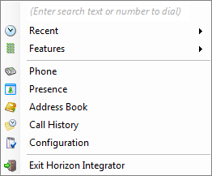
This will open the tray menu, which should look like this. From the top down we have;
- Quick dial box - you can type a number to dial or enter a name to find a contact
- Recent menu - quickly see recently dialled numbers and click to redial them
- Features menu - amend call settings such as do not disturb and call forwarding
- Phone - opens up the phone window, covered in more detail below
- Presence - opens up the presence window, covered in more detail below
- Address book - you can search for a user in your company directory or a user that is in a connected CRM
- Call history - opens the call history window that details your recent incoming, outgoing and missed calls
- Configuration - used to configure which CRM packages you integrate with
- Exit - use this to exit the software

Phone window

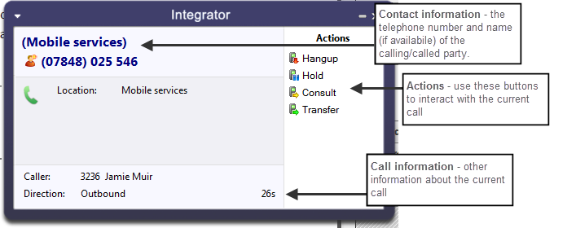
The phone window can be accessed by either selecting it from the tray menu (as shown above) or by double clicking the Integrator icon in the bottom right of the screen. The screenshot below shows the window during an active call.

You can use the Phone window if you want to control calls or show contacts. After you’ve used the software for a while, though, you’ll probably prefer to use the Preview window it can be more convenient and less intrusive.

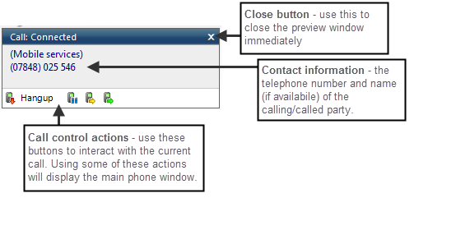
Preview window

The preview window will appear when a call is ringing or answered, and will look similar to the below.
Like the Phone window, the actions at the bottom of the preview window adapt to the state of the call. The example picture shows the actions that are available when a connected call is in progress.

Making calls

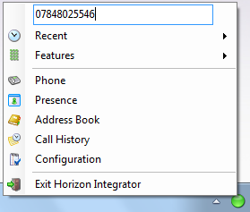
Integrator offers several ways of making calls using your PC without the need to pick up your handset and dial. Below are a few real life scenarios of where you may have a number stored that you'd like to dial and how Integrator can help make that simpler;
- A piece of paper
  - From the Integrator tray menu you can type the number into the text box at the top the hit enter. This will initiate a call to that number.

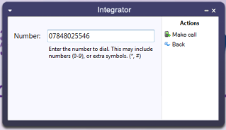
  - If you happen to have the phone window open you can start to type the number using your keyboard. Integrator will know that you're trying to make a call and will switch to the 'Make call' screen. Press enter or click 'Make call' to initiate a call to that number.

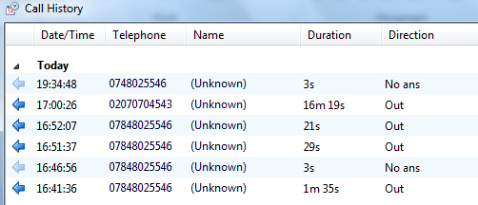
- Someone you spoke to on the phone recently
  - As long as you spoke to them on your Horizon phone then the call will be in your call history. From the tray menu select 'call history' and you'll see a list of your calls in reverse date order. Locate the caller from the list and click on their number to initiate a call to them.

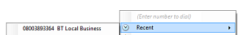
  - Alternatively, if they were one of the last 10 people you spoke to then they will show in your 'Recent' list. From the tray menu (or phone window) select recent and select their number to initiate a call.

Call control

Active call

The call control screen appears when you make or receive a call, with the same 'Call actions' appearing next to the Integrator icon in your notifications panel.
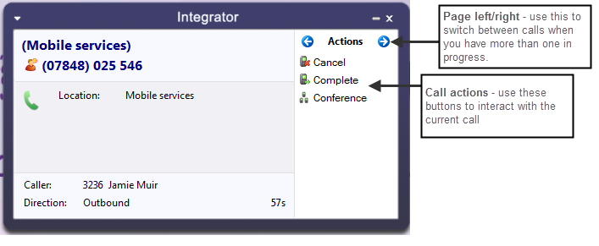

The phone window allows you to interact with the current call in a number of ways, including the transfer of calls. To do this you must be connected to the call you would like to transfer, i.e. it cannot be on hold or ringing.

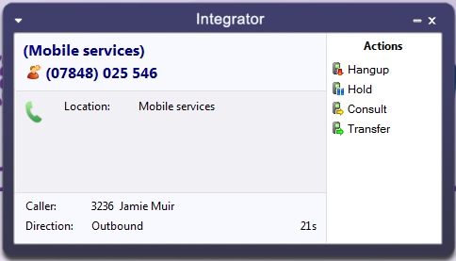
When you are connected the actions list looks like it does to the right. To transfer a call you do not need to place it on hold, instead press either the consult (if you'd like to speak to the other person first) button or transfer (if you do not want to speak to the other person first).

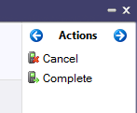
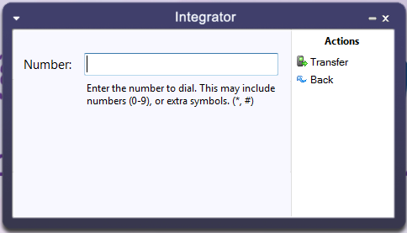
You are then presented with a screen similar to the 'Make a call' screen, but with the word Consult or Transfer to the right of the Number field. Your call is not on hold at this stage, but when you are ready enter the number to transfer to, then click;
- 'Consult' to place the current call on hold, while you speak to the other party. You can then press complete or cancel.

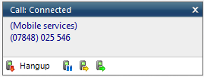
- 'Transfer' to put the call straight through to the other party
Note: all of the call actions on the main phone window can also be accessed via the preview window that appears next to the Integrator icon.

Ringing call

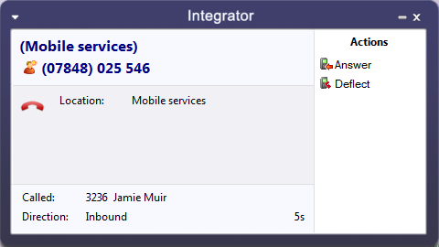
A ringing call can be either;
- Answered, which will answer the call on your Horizon phone
- Deflected, which will give you the ability to direct the call to an alternate number

Features
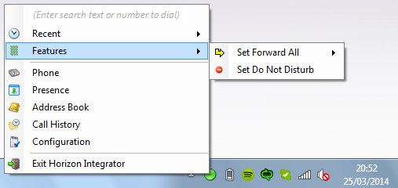
The Features menu provides you with options to control the behaviour of your phone. There are three options available from this menu; “Call settings”, “Set Forward All” and “Set Do Not Disturb”.

Set forward all

“Set Forward All” allows you to enter a number that will be called when someone calls your extension. Please remember that that your phone will not ring when this is set.

Set do not disturb

“Set Do Not Disturb” allows you to set your phone so that a caller will hear the busy tone when they call your extension.

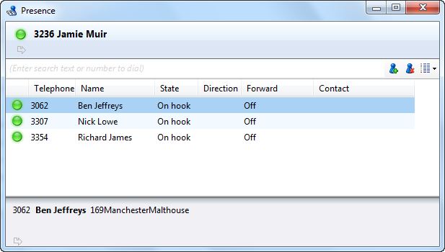
Presence

Presence provides a simple and quick way for you to check the status of your colleagues' extension. The window can be accessed from the tray menu by selecting 'Presence'.

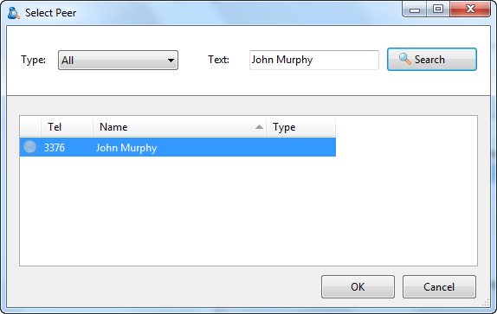
You can customise your list from this window by clicking the green plus icon, searching for the person you'd like to add and clicking 'OK'. Under 'Type' you can select either extension, to search by extension only, or all to carry out a free text search.
Note: the list is limited to 20 extensions / users

Colour | Status
Solid green | On-hook
Flashing red | Ringing
Solid red | Call connected
Flashing yellow | On hold
Solid grey | Off-line

The circle next to each of your monitored contacts will indicate the state of their extension. This key shows each of the possible states.

You can right click any of your monitored contacts and will be presented with appropriate option(s). If you are not on a call you'll have an option to initiate a call to that user. If you are currently on an active call you'll have the option to consult or transfer to that user - as described in the call control section.
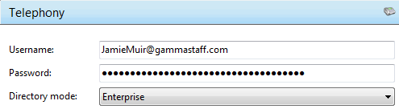
Note: by default the search will only look for users in the same group as you. If you want to search company wide you'll need to go to Integrator > tray menu > configuration > telephony > and update the Directory Mode to 'Enterprise'.

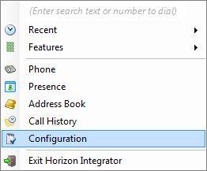
Settings and configuration

The Configuration section contains many options that allows you to customise your installation of Integrator. The following will cover the most common settings. If you select the Configuration menu item from the tray menu then you are given a page with options on the left hand side.

Telephony settings

These settings are covered in the 'Getting started' section.
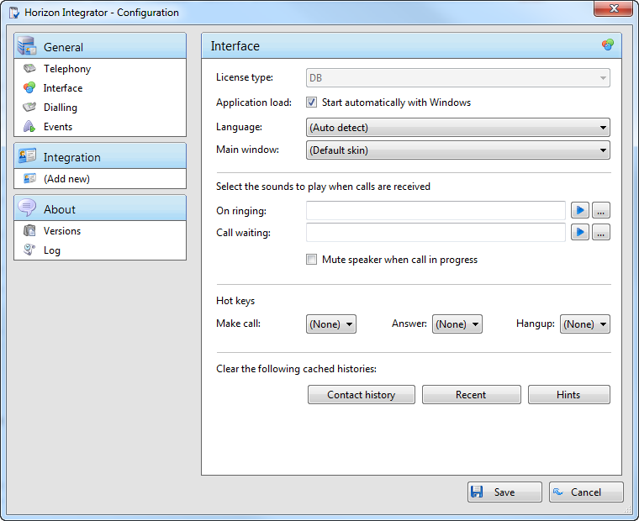

Interface settings

Interface settings lets you define some personal preferences and hotkey settings. Within the page you can;
- Set if you'd like Integrator to start with Windows
- Play sounds though your PC when calls are ringing or waiting
- Set hot keys for making a call, answering a call or hanging up
- Clear locally cached histories

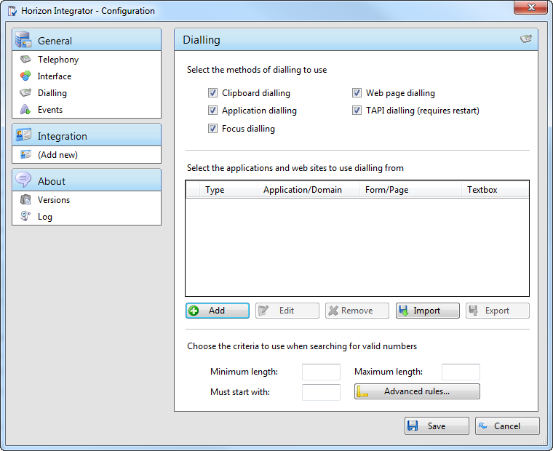
Dialling settings

This page allows you to turn on and off dialling from all the different types of application that Integrator supports.
As a review, the different methods of clipboard dialling are;
- Clipboard dialling (where you copy a telephone number to the clipboard and the software detects it),
- Web page dialling (where the software automatically scans web pages in Internet Explorer or other supported web browsers and converts anything that looks like a telephone number into a clickable hyperlink and adds new buttons next to telephone number fields that you have told it about),
- Application dialling (where the software adds new Dial buttons to applications that you have told it about),
- TAPI dialling (where any application that supports Microsoft TAPI can dial through Integrator) and Focus dialling (dynamically recognize any numbers in textboxs that looks like the phone numbers and allows to dial that number out).
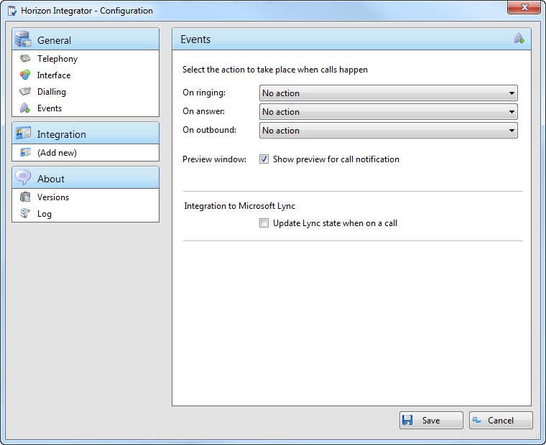

Events settings

You can force Integrator to either show the Phone window or pop the contact when certain events happen. Just select the relevant action from the relevant dropdown list: On ringing, On answer, or On outbound. You can also turn on or off the unobtrusive Preview window for all calls by ticking or clearing the box.
Integration to Microsoft Lync allows you to update your Microsoft Lync state when you are on a call. By ticking the box your Microsoft Lync status will change to “In a Call” when your extension is on a call. Note: Your Microsoft Lync status will only change when your PC is powered on and Integrator is running.

Integration settings

The Integration pages allow you to see and modify the databases that you have set up integration with. Integration means the database will be searched when calls happen to convert telephone numbers into names; and the database will be searchable manually from the Address Book window; and contacts that are found in the database can be “popped”.
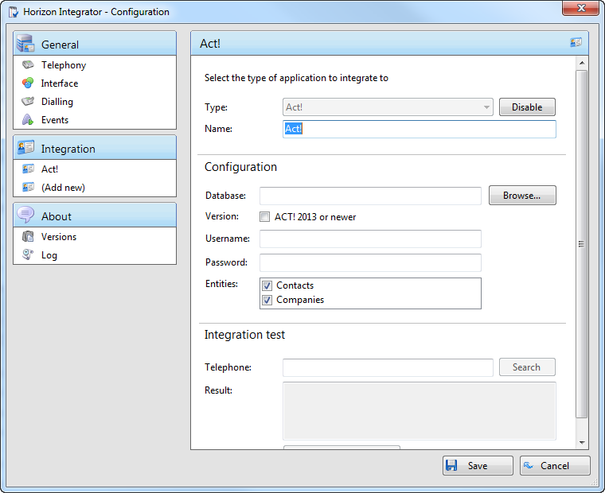
Please refer to the individual addin guide if you wish to add a database.

