Horizon Integrator

Web page dialling guide

# Contents

Contents 2

Introduction 3

Configuration 4

Microsoft Internet Explorer 5

Updating Internet Explorer 5

Configuring Internet Explorer 5

Google Chrome 6

Updating Chrome 6

Configuring Chrome 6

Mozilla Firefox 9

Updating Firefox 9

Configuring Firefox 9

Safari 11

Configuring Safari 11

# Introduction

This document will guide you through the process of configuring web page dialling for Microsoft Internet Explorer, Google Chrome, Mozilla Firefox and Apple Safari web browsers.

Dialling in Firefox is achieved with the assistance of Codepad’s Telify add-on which is partially installed during the Integrator installation; a small amount of manual configuration remains. See below each browser configuration.

# Configuration

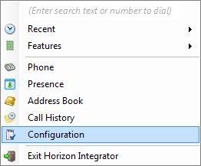

Open the Integrator configuration menu by right-clicking on the tray menu icon and clicking the ‘Configuration’ option.

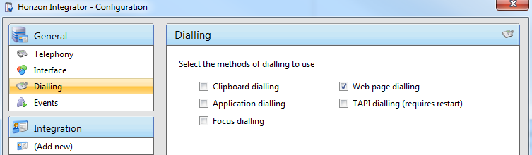

Click ‘Dialling’ to show the dialling options and ensure that the ‘Web page dialling’ checkbox is checked.

Click ‘Save’ to store and apply the settings. You may need to restart Integrator and any preconfigured open browsers for the changes to take effect.

# Microsoft Internet Explorer

## Updating Internet Explorer

Internet Explorer is updated through the Windows Update program. If you want to check that your Windows operating system is up-to-date, run ‘Windows Update’ from the Start menu or the Control Panel. Windows Update will check to see if there are any available updates and list any it finds including those for Internet Explorer. Make sure the Internet Explorer-related updates are selected and click ‘Install Now’; it may take a while to install the selected updates and you may need to restart your computer when the installation is complete.

## Configuring Internet Explorer



As long as you have already enabled 'Web Page Dialling' as detailed in the Configuration section then no further configuration is required. Telephone numbers found on web pages displayed in Internet Explorer will be converted to clickable hyperlinks that dial the number.

# Google Chrome

## Updating Chrome

Google Chrome updates automatically if it detects that a newer version is available and usually takes care of this in the background without intervention from you. When a newer version is available, a small arrow can be seen near the spanner icon. You can check which version you have by clicking on the spanner icon and then clicking ‘About Google Chrome’.

## Configuring Chrome

There are two ways to configure your Chrome web browser:

1. 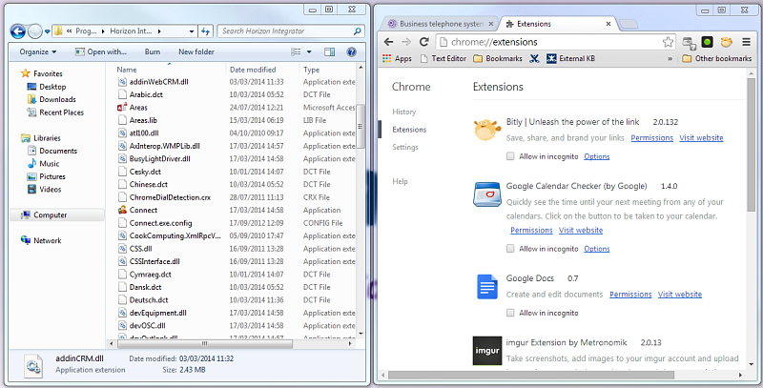By adding ChromeDialDetection.crx extension from Integrator's directory.
2. Open Windows Explorer or My Computer and navigate to Horizon Integrator's program folder; it is usually in the ‘Program Files’ folder on the C: drive. Also open Chrome and go the extensions page (Click on the ‘Customize and Control’ icon and select ‘Settings’. Select the ‘Extensions’ option on the left hand side of the screen.) Sit the two windows side-by-side.
3. 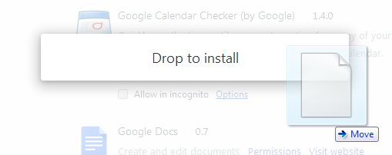Click and hold the mouse button down on the ‘ChromeDialDetection.crx’ file in Windows Explorer/My Computer and drag the file over to the Chrome window, then let go of the mouse button to drop the file into Chrome; this installs a version of the dialing add-on in Chrome.
4. 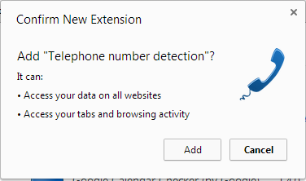A window will pop up giving you the details of what the dialing add-on will be able to access, click ‘Add’ to proceed with the installation. The installation shouldn’t take very long. When it is complete, a notification bubble will be displayed near the top of the Chrome window to let you know.

If the ‘ChromeDialDetection.crx’ file is not present in the Integrator program folder or you are unable to install it by dragging it on to the Chrome browser; you will then need to update Integrator to get a new ‘ChromeDialDetection.crx’ version or…

1. Download it from Chrome Web Store by either following this link: <http://goo.gl/8UopvR> or going to Chrome browser Settings > Extensions
2. 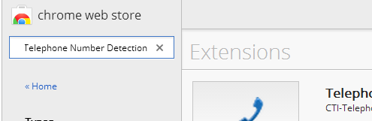Click on the ‘Get more extensions' link
3. 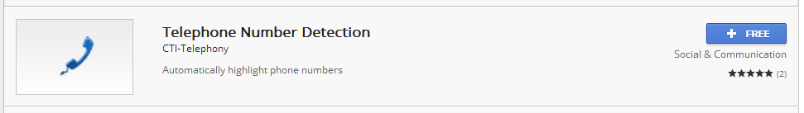Within the Chrome web store search for “Telephone Number Detection"
4. Click on the “+ Free” icon to add this extension
5. Click add
6. ‘Telephone Number Detection’ is now added to your chrome browser extensions

* Note - When adding the extension to Chrome you may receive the following notification, please press continue to accept the installation.



Loading the ‘Telephone Number Detection’ extension via the Chrome Web Store will cause the extension to automatically update whenever a new version is published (unless Chrome browser is configured differently).

Note: the extension can be disabled/enabled by clicking the icon on the top right of the screen.

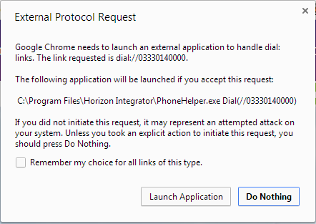Chrome will now be able to identify numbers and convert them into hyperlinks you can click to dial the number. The first time you use web page dialling in Chrome, a window will pop up with a message about external protocols. Click the ‘Remember my choice for all links of this type’ check box to prevent the message from reappearing and then click ‘Launch Application’ to dial the first number.



# 

# Mozilla Firefox

## Updating Firefox

Firefox is configured to detect updates automatically and then let you know; you just need to click ‘OK’ when asked if you want to install the latest update. If an update has been pending for more than 24 hours, Firefox will remind you. You can check which version you have by clicking the menu button at the top-right of the browser window, clicking the ‘Help’ menu (indicated by a question mark) and then clicking ‘About Firefox’.

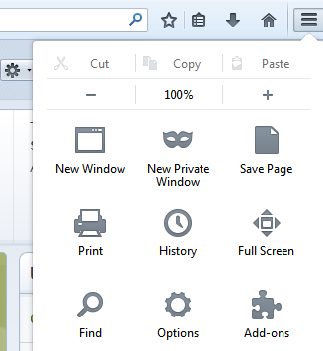

## Configuring Firefox

Open Firefox and click the menu button in the top-right corner to reveal the main menu, then click the ‘Add-ons’ option; a new tab will be opened that gives you access to the various extensions and plugins that have been installed. The files that make up a modified version of Codepad’s Telify dialing add-on are already installed in the correct location so you don’t need to install it but it may need enabling (which is what we are checking now).

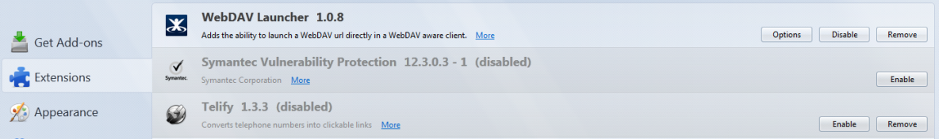Click the ‘Extensions’ option in the menu on the left-hand side of the ‘Add-on Manager’ tab to display the list where Telify resides. If Telify’s row is greyed out with an ‘Enable’ button, then it is disabled; just click the ‘Enable’ button and then the ‘Restart now’ button when prompted.

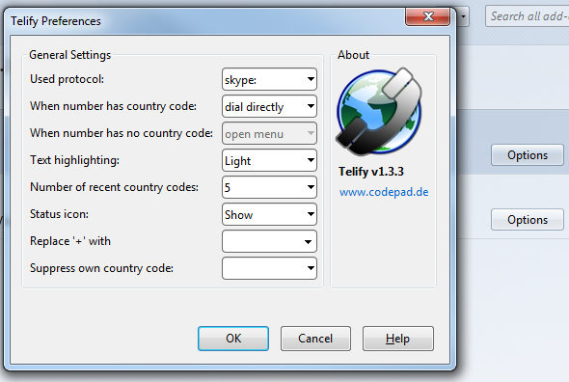If Telify is not present in the list of extensions, you need to update Integrator.

Once enabled, you can modify Telify’s behavior and the appearance of the converted numbers by clicking the ‘Options’ button which now appears on Telify’s entry on the ‘Add-on Manager’ tab.

Make sure that ‘callto:’ is selected in the ‘User protocol’ dropdown box, otherwise feel free to experiment; you can always return to the standard settings (seen opposite) if you run into trouble.

Telephone numbers found on web pages displayed in Firefox will now be converted to clickable hyperlinks that dial the number.

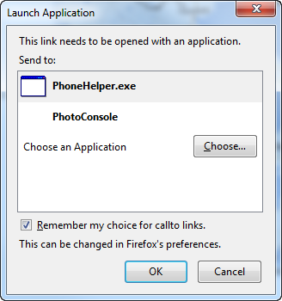The first time you use dialing in Firefox, a message window will pop up informing you that the link you have clicked on needs to be opened with an application.

Click the ‘PhoneHelper’ option in the ‘Send to’ box and make sure the ‘Remember my choice for callto links’ check box is checked as in the picture opposite; this is to prevent the message window appearing in future. Click the ‘OK’ button to save the settings and dial the first number.

Note: if phone helper does not appear, you can select 'Choose' and browse to the Integrator program folder - then select 'PhoneHelper'

# Safari

## Configuring Safari

Start by opening Windows Explorer or My Computer and navigating to Integrator's program folder; it is usually in the ‘Program Files’ folder on the C: drive. Also open Safari and go the extensions page (Click on the cog and select ‘Safari Extensions’. Sit the two windows side-by-side.

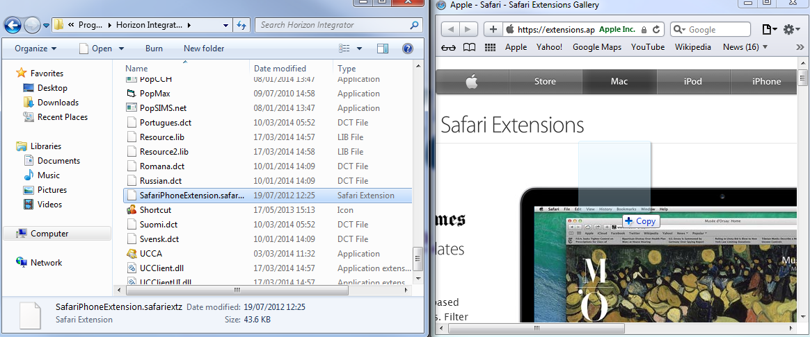Click and hold the mouse button down on the ‘SafariDialExtension.safariextz’ file in Windows Explorer/My Computer and drag the file over to the Safari window, then let go of the mouse button to drop the file into Safari; this installs a version of the dialling add-on in Safari. If the ‘SafariDialExtension.safariextz’ file is not present in Integrator's program folder, you need to update Integrator.

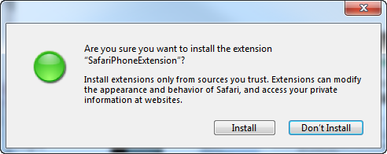

A window will pop up asking you if you are sure you want to install the software, click ‘Install’ to proceed with the installation.

Safari is now configured for web page