Receptionist console

User guide 1.0

|  |  |
| --- | --- |
| **Date:** | 1st September 2013 |
| **Presented by:** | Chris Shaw |
| **Position:** | Product Manager-Hosted Voice |
|  | 0333 240 3016 |
|  | 07848466283 |
|  | Chris.shaw@gamma.co.uk |

Contents

Introduction and purpose 4

Common deployments of the receptionist console 5

Fixed Receptionist Console 5

Soft Receptionist Console 5

Multiple site receptionist 5

Monitoring of key call routing and basic CRM 6

Business continuity 6

Using the service 7

Getting started 7

Console overview 8

Settings 9

Help 10

Sign Out 11

User 11

Call Action Buttons 11

Call Console 12

Contacts 15

Queued Calls 17

Call Notification Window 18

Managing calls 19

Multiple calls 19

Timers 20

Routing involving a contact 20

Picking up a contact on a monitored extension 20

Redialling previous numbers 21

Dialling a speed dial 21

Call History 21

Transferring calls 21

Call Park 22

Fault diagnostics 24

3rd Party Hardware 24

Frequently Asked Questions 24

Appendix A – Keyboard shortcuts 26

# Introduction and purpose

The Horizon Receptionist Console has been designed to be used in conjunction with the core Horizon service, and enables the attachment of a web based attendant console, specifically developed for hosted environments and accessible through any web interface.

Through this console the full set of call control features, large scale line monitoring, queuing, multiple directory options, and views are available, which are all key requirement for large or distributed organisations.

This document is designed at explaining the core features of the receptionist console, as well as the steps needed to install and access the service and the use cases it can be applied to.

# Common deployments of the receptionist console

The traditional receptionist role combines both screening of incoming calls for key areas of the business as well as ensuring core call routing is working as efficiently as possible to deliver calls to the right locations.

Through the application of the receptionist console our aim is to provide the following real world benefits:

* An easy to use interface aligned with the core Horizon service
* An ergonomic design that follows a natural workflow of a call from left to the right side of the screen
* Improved efficiencies as only "valid" options are presented to the user
* Professional call handling as critical information is available in "real time" to the user
* Web based interface accessible through any web browser even whilst on the move

## Fixed Receptionist Console

The fixed receptionist console utilises either Cisco or Polycom phones and sidecars to provide a "bank" of up to 50 monitored contacts, in order to manage incoming calls and deliver them to appropriate resource.

In this use case the receptionist would traditionally answer or blind transfer all incoming calls to key contacts.

This use case can still if required be combined with the soft receptionist console

## Soft Receptionist Console

The soft receptionist console utilises a web based attendant console to monitor and manipulate incoming calls and call routing of core features such as call queues. Through the console the receptionist is able to monitor or search a directory of up to 800 contacts.

In this use case like the fixed console the receptionist can manage multiple calls, however is able to do so through an easy to use web interface providing additional information about the call. Additional features are also available to attach a caller to a specific extension for when it becomes available, through to managing ad hoc conference calls, and adjusting the order of callers in a queue.

This use case can if required also provide a solution just for a single number or user however is predominantly used for larger or multiple site solutions.

## Multiple site receptionist

Due to the cloud based structure of the core Horizon service and receptionist offerings, the ability to have just one receptionist managing multiple sites and main numbers is achievable

Through this use case call routing shared over multiple locations can easily be monitored, as well as the ability to bring in additional resource during busy periods at specific sites.

## Monitoring of key call routing and basic CRM

Whilst the receptionist role is the main one met by this new offering, managers of specific teams may also find it of use to monitor key call queues or users, and to keep specific customer notes.

Through seeing the number of callers within a call queue, additional resource or routing could be implemented. At the same time the ability to leave notes in the system against a directory contact both internal and external means a base level of CRM is achievable, as well as any internal notes being visible such as someone being away on leave.

## Business continuity

Due to the core service being hosted in an ISO accredited carrier data centre the functionality provided to a receptionist user is available wherever they are.

As such in the event of not being able to get to your usual office location you are can use forwarded landline and/or mobile destinations as well as hot desking to deliver calls to your phone. At the same time the console for management purposes can easily be accessed over home based devices or iPads/mobile broadband connections.

# Using the service

## Getting started

As one of the key benefits of the service the soft receptionist console is hosted within a core carrier class data centre that is ISO accredited, and is accessible through a secure web connection through any common web browser.

However the recommended and fully supported deployment is based on:

- A Windows platform

- Running Internet Explorer

- Running without tabs in order to enable the "Focus Window for incoming calls to work"

In order to access the landing page of the service the following address should be entered:

<https://xsp.unlimitedhorizon.co.uk/receptionist>

This should direct you to the main login page for Horizon

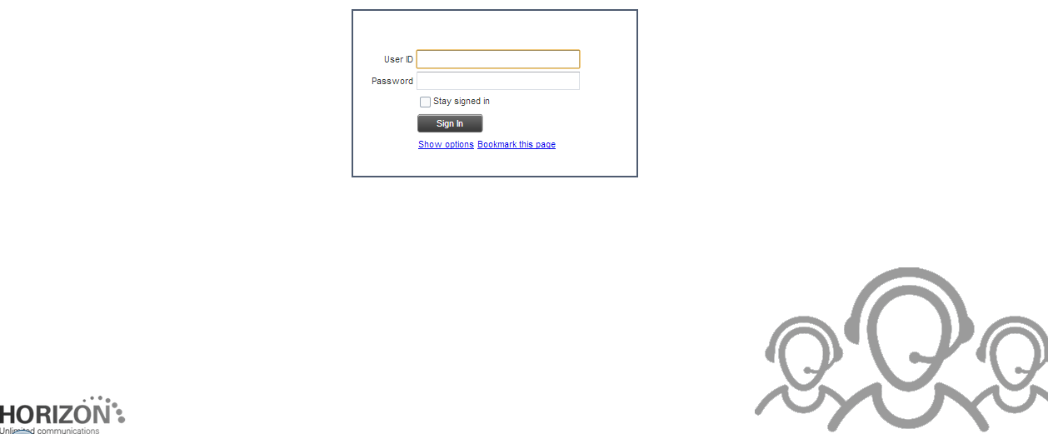

Please note that the minimum required screen resolution for the console is 1024 x 768 pixels, and that multiple different user sessions cannot be run from a single machine at the same time.

In order to access your user account you simply need to then enter the provided username and password and click "Sign in" to reach the home console screen of the service.

The home screen of the service will default to the standard view when you first login however will "save your workspace" when you exit the console on each use.

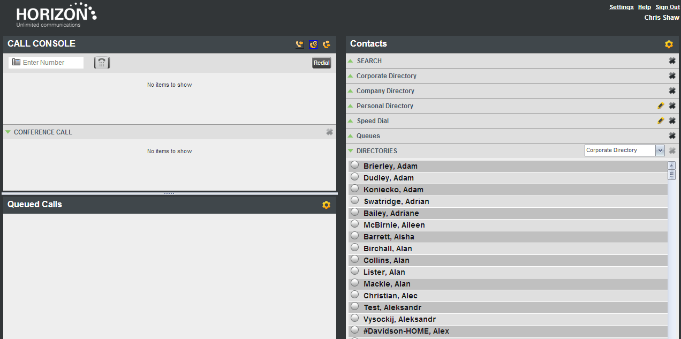

## Console overview

When you first login the main screen you see, and will be using is the call console which is split into 3 sections, Call Console, Contacts, and Queued Call.

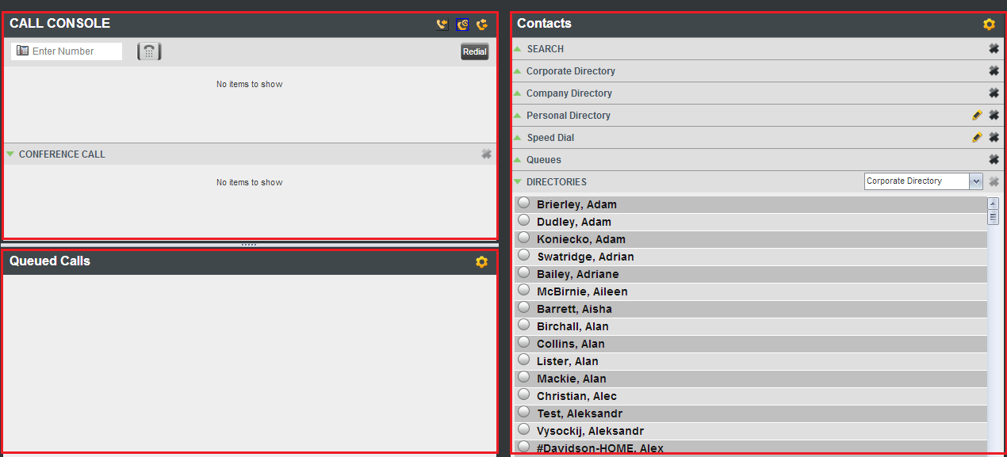

Prior to exploring these areas in the following sections it is also beneficial to review the options on the toolbar to help configure the service to your requirements.



### Settings

In order to ensure the soft console is configured to your day to day use of the service a number of options are available to configure the service.

Simply click the relevant tab, and adjust the settings required.

#### General - Workspace

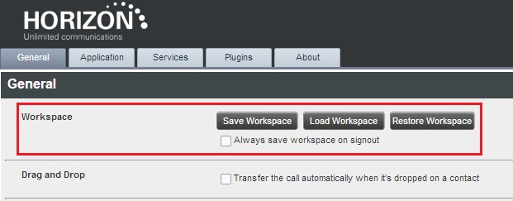

The workspace within the call console can be configured to always show your pre-defined view of contacts or queues when you first login to the service.

Within this setting you have the ability to "Save", "Load", or "Restore" a workspace as well as ensuring your space is automatically saved when you log out.

#### General - Drag and Drop

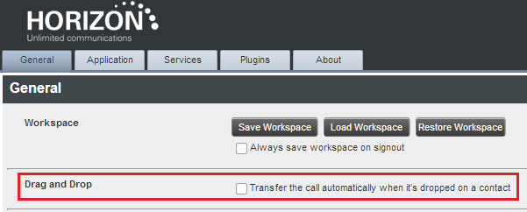

The call console has the ability to enable drag and drop of incoming calls onto key contacts. Through this functionality instead of performing multiple clicks to action the required move a call can simply be dragged to the contact to perform an action

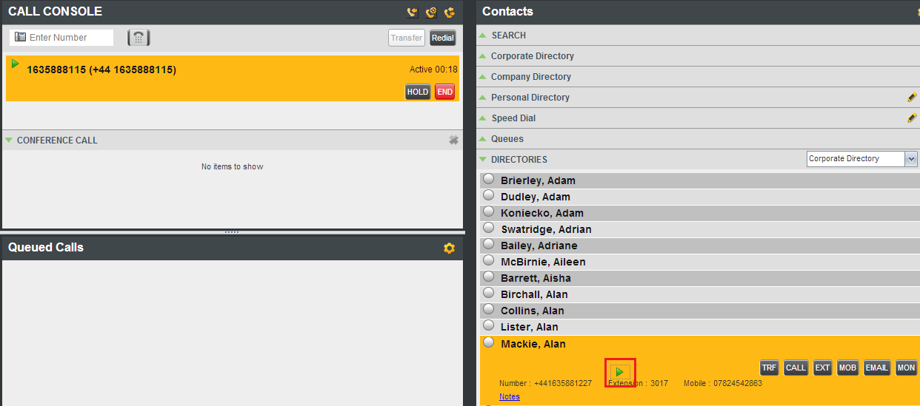

To enable this functionality simply click the tick box

#### Services

As well as managing your telephone calls, the receptionist client is also able to manage features/services assigned to your user account. To activate these simply click on the relevant tick box and specify the required information.

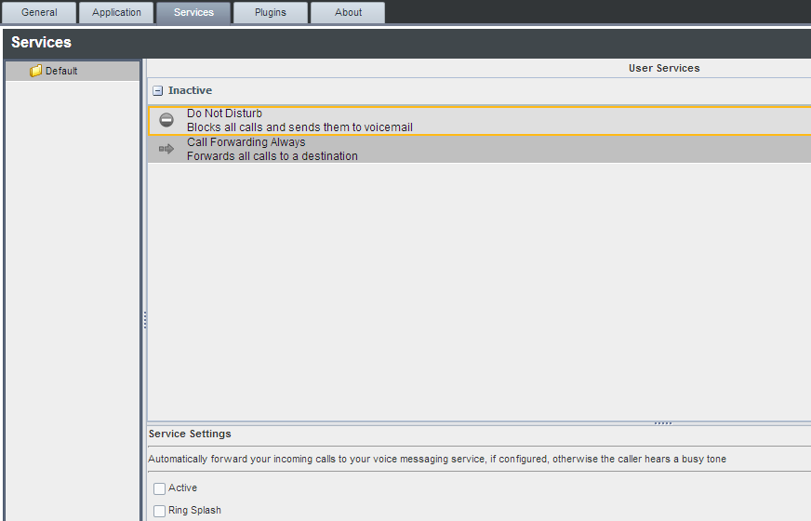

For further details on these features please consult the main Horizon documentation

#### Plugins

The receptionist console has the ability to also interwork with your Windows desktop by bringing the Receptionist Console window to view from a minimised state when incoming calls are visible.

To configure this feature you simply need to define your requirements under the Plugin section

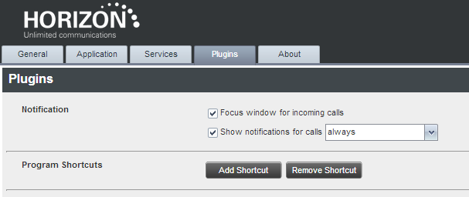

Please note that the "Focus window for incoming calls" will only work where the console is minimised not "hidden" on the screen, and where a "non tabbed" browser window is used.

#### About

Within here you will find details of the core application and the current version of software. These details may be needed when raising support calls

### Help

This link will lead you to this user guide, however further help functions will be made available through here and documentation provided by your service provider

### Sign Out

This link will sign you out of the receptionist console, and if not set by default will ask if you want to save your "workspace".

Please note that logging out of the console does not log you out of your fixed phone!

### User

The name located under the above options confirms which Horizon account you are logged in as, and shows the following additional information to the left of the name:

doNotDisturb.png Do not Disturb (DND) enabled - Has precedence over all other icons except Voice message

callForwardingAlways.png Call Forwarding Always (CFA) enabled

stateBusy.png Busy Call state

 Voice Message

Call parking information is also shown with details of the first and last name and the extension the call is parked against

### Call Action Buttons

When managing incoming or making outgoing calls there are a number of call action buttons that could display within the relevant sections of the console.

As part of the design of the console only valid options will be displayed to the user in the relevant section.

The full list of buttons are as follows:

dialButton.png This dials the number entered into the dialler box. It can be used during most call states to transfer to external numbers or to implement any required codes.

callButton.png This places a call to the selected contact or to a number from the call history logs

redialButton.png This redials the last dialled number

extButton.png This dials the contact's extension number

mobButton.png This dials the contact's mobile number

emailButton.png This brings up a new email message window with the contact's email address added

transferButtonInDialer.png This transfers a call to an ad hoc number entered in the dialler

transferButton.png This transfers a call to a selected number or contact

transferToVoicemail.png This transfers a call to the selected contact's voice mail

answerButton.png This answers an incoming call, answers an unanswered call to a monitored contact, or resumes a held call

holdConferenceButton.png This places the call on hold

endCallButton.png This ends the call selected

conferenceButton.png This establishes a conference call or adds a call to a conference

ParkButton..png This parks a call on a contact

MonitorButton.png This starts monitoring the state of the selected contact (Busy Lamp Field)

promoteButton.png This promotes a selected call to the next higher priority bucket

retrieveButton.png This retrieves a selected call from the queue to the receptionist's device

reorderButton.png This changes a selected call's position in the queue

deleteCallLogButton.png This deletes a call log from call history

### Call Console

The call console is the initial part of the screen where all calls will be shown and appropriate management of the call routing can be implemented.

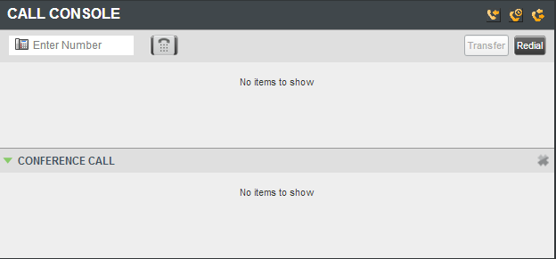

Within this section the following sections are available to assist with managing calls

#### Call Console - Header

Within the header of the call console you will see a number of icons allowing you to access additional functionality:

 Call History - This allows you to access a list of previous calls

 Call Waiting - This allows you to enable Call Waiting

 Auto Answer - This allows you to enable Auto Answer, connecting every call to your attached phone straight away.

#### Call Console - Dialler

The dialler within the Call Console section allows you to type any number (with the appropriate country code if applicable) to connect a call. To do so simply type the number into the "Enter number" box, and click on the dial icon



The action buttons to the right of this section become active depending on the relevant call state and allow further actions to be taken to enable call routing.

When using the dialler to make outgoing calls please note you will need to answer the incoming call on the console or on your phone to connect to the number dialled.

#### Call Console - Current Calls

Beneath the dialler and header is the current calls section of the console where all active calls being dealt with will be shown

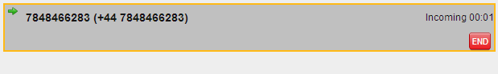

Each call within here is listed on a separate line with the following information:

* Number of the calling party - Recalled information also shown when being recalled from a specific destination
* Call state icon - Visual representation of the state of the call
* Call state name - The display name of the current call state
* Call duration - This is the duration of the call from the time it was put into the current state. For example if a call has been put on hold then this will be the on hold time for that call
* Actions buttons - As with the "header" specific actions buttons depending on the action you can take will be displayed

#### Call Console - Conference Calls

Also within the Call Console is the Conference Call panel which displays any established conference calls and allows you to manage them as required. Please note as you only have a single primary device you can only be involved in one conference call at a time.

In order to establish a conference call you need to have two or more calls active within your main call console, and can then take further actions against these calls.

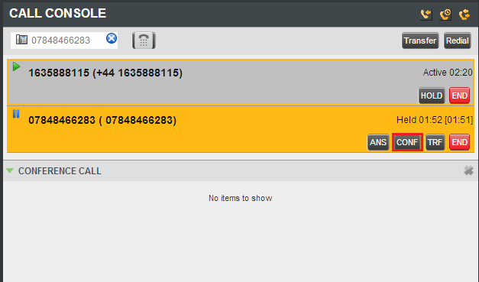

Pushing the conference button then adds the calls and your line into conference

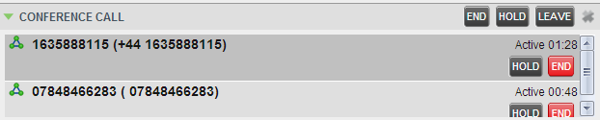

Once established you then have further options you can perform

holdConferenceButton.png Allows you to place all conference members on hold

answerButton.png Resume allows you to resume the conference

leaveConferenceButton.png This allows you to leave the conference, but maintain the bridge for the other parties

endConferenceButton.png This will end the conference and all parties will be disconnected

#### Call Console - Call States

During both normal and conference calls the following call states and actions can be performed:

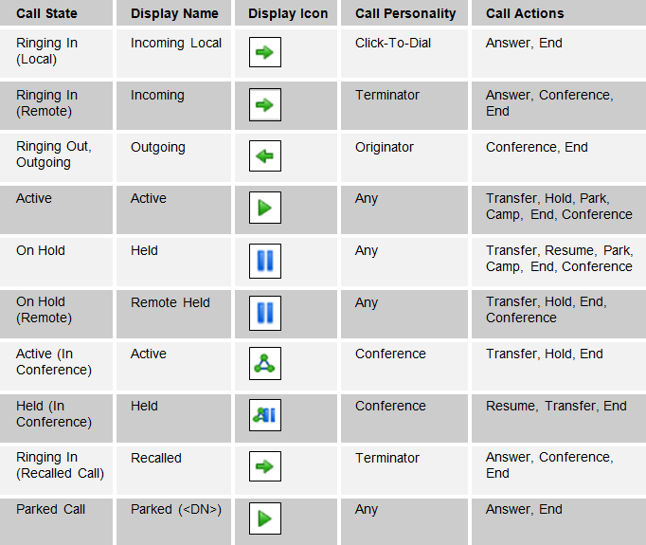

### Contacts

The contact section of the receptionist console provides you with all contacts loaded into the Horizon interface and splits them into the relevant categories allowing quick and easy connection of calls.

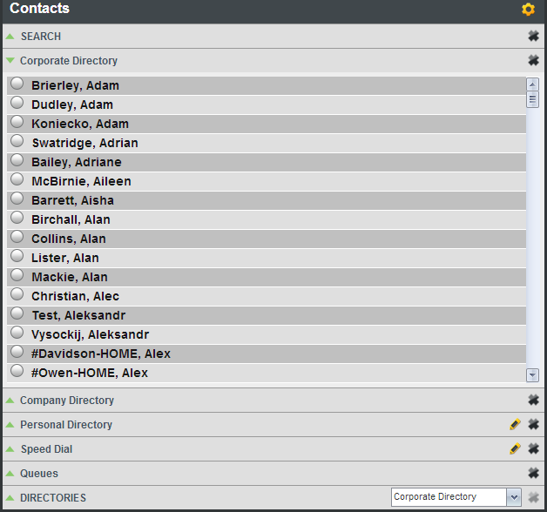

You can browse contacts by using the scroll bars and directory sections, or through the search at the top of the pane.

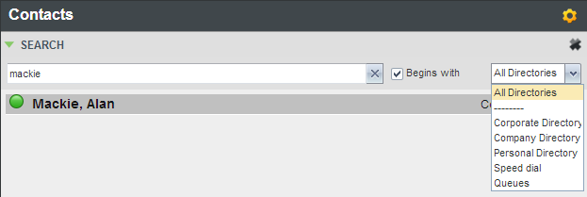

Once a contacted is selected you can then see further information about them as well as relevant action buttons being available.

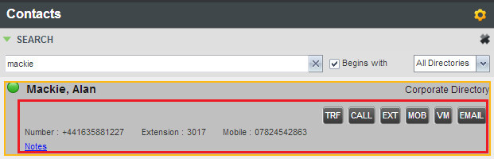

#### Contacts - Adding directory contacts

With the exception of the "Corporate directory" which is set by the users provisioned on your Horizon service, all other directory entries can be amended within the main Horizon interface.

Please see the in interface help within Horizon or the user guide for further information on adding and editing directory details.

#### Contacts - Adding speed dials

All speed dial contacts can be added and amended against the user's account within the main Horizon interface.

Please see the in interface help within Horizon or the user guide for further information on adding and editing directory details.

#### Contacts - Adding call queues

A user's membership of a call queue is controlled through the Horizon interface under call groups

Please see the in interface help within Horizon or the user guide for further information on adding a user to a call queue.

#### Contacts - Adding Notes

Against a contact specific notes can be added for internal use, or to assist others using the receptionist console.

To add a note simply clicks on the highlighted blue text against the contact.

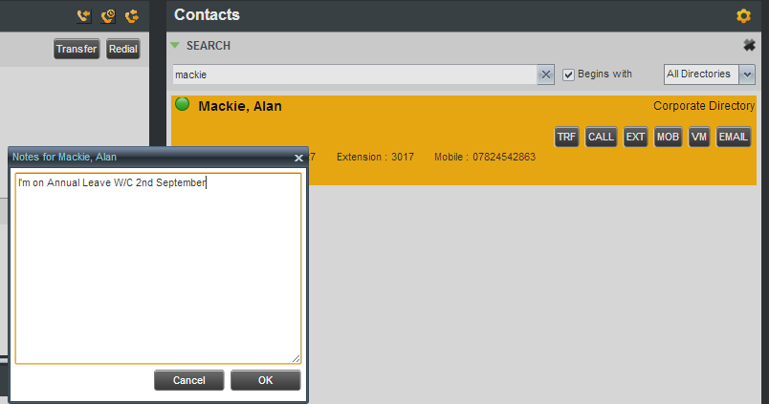

Type the note you wish to make and click "OK" to save the note against the contact.

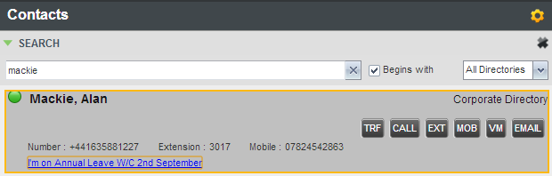

### Queued Calls

The queued calls section of the receptionist console lets you see all call queues (up to 5) that your user account is able to see within the Horizon service.



For each of these call queues the following information is shown:

* The name of the Call Queue
* The primary number of the Call Queue
* The number of calls against the maximum queue size
* The number of calls in the queue against the maximum queue size

When you expand the call queue panel a list of calls queued, their priority, and their position in the queue, is shown.

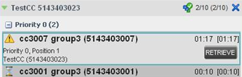

For each call the following information is given:

* Call status icon - a graphic representation of call state which could be one of the following:
  + waiting.png - The call is queued and waiting to be answered
  + AnnouncementIcon.png - An announcement is being played to the caller
  + reorderedCallIcon.png - The position of the call in the queue
  + bouncedCallIcon.png - The call has been bounced
* Name (if available) and phone number of the calling party
* The total call time

Clicking a call expands the call to show additional information including:

* Position in the call queue
* Name (if available) and phone number of the call queue that was called
* Additional action buttons to implement further routing

### Call Notification Window

If the browser is integrated with the Java plug-in a non-intrusive call notify window will be shown on the bottom right corner of the screen when the receptionist receives a call. This window displays the available caller information.

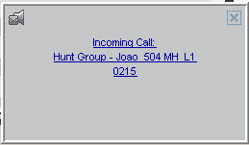

When a call is address to the receptionist, the option to answer the call or redirect it to voicemail is available from the call notification window.

## Managing calls

Using the previous section to explain the various buttons and areas of the receptionist console you should now be ready to manage calls using the receptionist console.

In order to do so please login to the receptionist console using your user credentials and ensure your Horizon phone is either logged in through hot desking or online. If it is not then incoming calls will be diverted to call forwarding or twinning and you will not have the option of answering calls in the console window

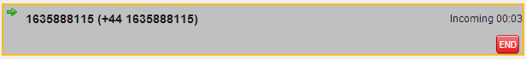

To answer an incoming call simply use the "ANS" button against the required incoming call

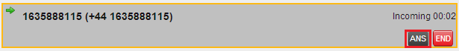

For outgoing calls simply select the user and click "Call"

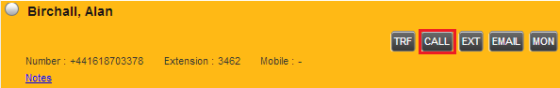

Or use the dialler to type a number and click the "Dial" icon

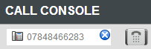

A call can also be made from the phone and would also show within the receptionist console.

### Multiple calls

Multiple calls can be managed either through the receptionist console or from using the standard features of the Horizon service.

To move between calls in the receptionist console simply click on the call you'd like to select and the relevant "Action" button such as "ANS"

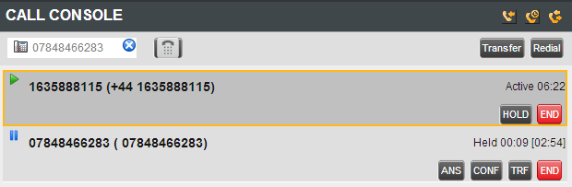

### Timers

Timers are visible within every call visible in the receptionist console and provide real time information to the user in order to make informative choices around call routing

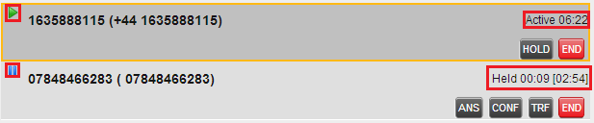

The latest state timer is always shown to the right of the total time shown in brackets

### Routing involving a contact

Where a call needs to be routed to a contact within the contact section of the console and drag and drop is enabled (under settings if not setup) you can simply drag the call from the call console to the relevant contact.

As the contact is dragged a small green arrow appears and you can place this on the required contact opening it up. To action a transfer or other options simply release the drag and then click the required "Action" button.



### Picking up a contact on a monitored extension

Where you have monitored a contact in the contacts section you are able to pick up incoming calls for them when their monitored state is ringing, depicted by a yellow call state indicator.

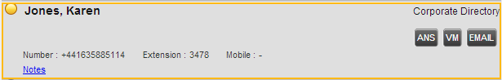

Once you have selected the contact you can then take one of the following telephony actions:

answerButton.png Answers the call on your phone

transferToVoicemail.png Sends the incoming call to the users voicemail

### Redialling previous numbers

In order to redial previous numbers you can either use the "Redial" button at the top of the call console or the call back feature within the call history section.

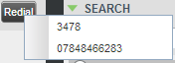 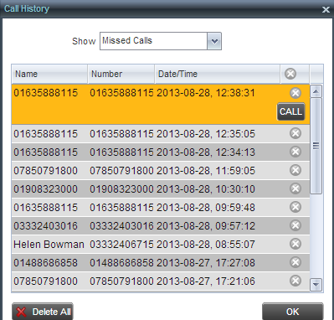

### Dialling a speed dial

In order to dial a speed dial you have setup within the Horizon interface simply open the speed dial section within the contact pane and click "Call" next to the required contact

### Call History

If you miss a call or wish to check all calls made, received or missed, you can simply click on the call History icon to ask the logs.

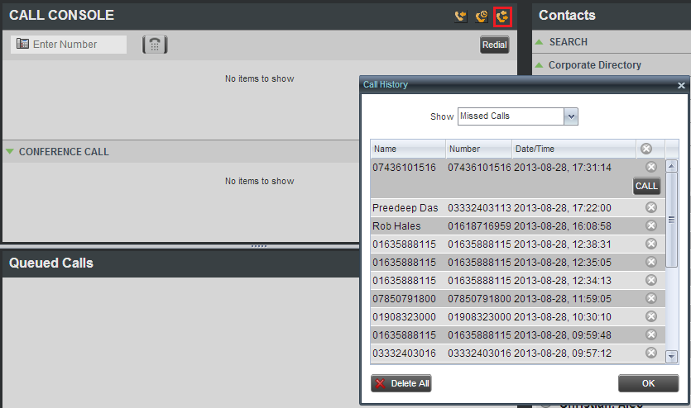

From here you then have the option to "show" the types of calls you wish to view (missed calls set as default), and then take further options against each contact to call them if required. A "Delete All" button is also provided to reset the log if required.

### Transferring calls

As with using the Horizon IP phones there are number of ways in which a call can be transferred to a contact.

#### Blind Transfer

A blind transfer occurs when a call is transferred without an introduction to the transferred contact, and can occur in any call state allowing quick and easy management of incoming calls from known callers.

To action a blind transfer, select the call in the call console to transfer, then either enter an external number in the dialler, or select on contact before clicking the "TXR" button. This will then transfer the call and it will be removed from the call console window.

Using monitored contacts you can identify if a user is busy or not prior to transferring the call

#### Consultative Transfer

A consultative transfer occurs when a call is transferred to a contact with an introduction to that contact to see if they wish to take the call, and can occur in any call state allowing quick and easy management of incoming calls from known callers.

To action a consultative transfer select the call in the call console to transfer and put it on hold. Contact the required contact and ensure they answer as to ascertain if they wish to take the call. When ready to action the transfer select one of the two calls and move the mouse over the non-selected call to click the "TXR" button.

The calls are then connected and removed from the call console.

#### Transfer to voicemail

You can transfer an incoming call to any monitored contact or your own voicemail whilst a call is in any call state allowing quick and easy management of incoming calls from known callers

To action a transfer to voicemail select the call in the call console to transfer and select the contact you wish to transfer the call to. Once the contacts detail is open simply click on the "VM" button of the contact to transfer the call.

#### Transfer to call queue

You can transfer an incoming call to a call queue in any call state allowing quick and easy management of incoming calls from known callers.

To action a transfer to a call queue select the call in the call console to transfer and select the required call queue from the contact section. Once the queue details are available simply click on the "TXR" button of the queue to transfer the call

### Call Park

You can also park a call against a conduct or hunt group which allows other contacts to then pick up the call. After a set amount of time the call would be returned to the original user to ensure it is always dealt with.

To perform a call park simply select the call in the call console and click on the "Park" button

# Fault diagnostics

The receptionist console is a separate system from the main Horizon interface, but at the same time does rely on configuration from it. As such prior to raising any faults the routing of user accounts, hunt groups, and other settings should always be checked by testing the existing functionality without using the receptionist console interface.

Where a fault is identified on the receptionist console a fault should be raised with the relevant support team in order for this to be investigated.

## 3rd Party Hardware

The desktop receptionist console will in the main be applied to desktop or laptop devices which Horizon has no control over, nor can offer support on.

As such support of these devices and services/programmes outside of the receptionist interface are not supported by the Horizon support desk and should be referred to the equipment provider/maintainer.

## Frequently Asked Questions

Status doesn't indicate if the user is available

Unlike presence the BLF indicator or contact monitoring indicator only identifies if the phone is not currently in use, it does not state if a user is available to take a call.

Call notification is not showing the leading 0 on the call notify window

This is a known issue which is currently under investigation

Can I have the console in a different language?

To simplify the initial release of the receptionist console only English has been implemented, however other languages are available on request, and where there is strong business case.

Parking a held call doesn't clear the call from the user

If a call is on hold and the receptionist presses the "Park" button, the call is not cleared from the user's phone and the call has to be un-held to proceed with the park procedure. This is a known issue which is currently under investigation

My call is showing as active even though it has been rejected

We have seen in some rare instances calls still showing as live when generated from the receptionist even when they have been rejected by the called party. This is a known issue and is currently under investigation.

There is no button to resume a held call

The button is labelled "ANS" instead of unhold

How can I stop monitoring a contact?

For dynamic monitoring of contacts it is not possible to remove a monitored contact, however the system will start to remove old monitored contacts when the limit of 800 users is reached.

The console isn't displaying newly assigned features

The receptionist will only pick up the latest configuration of a user's account when originally logged in. As such if changes are made it is necessary to restart the application by pressing F5.

Polycom phones don't handle automatic answer for click-2-dial call if engaged on another call

This is a current limitation of the Polycom phones and has been raised with to them

I don't always connect first time when pushing the "Enter" key on my keyboard when using the dialler

This is working as design however can cause confusion as the dialler will first try and guess the phone number being entered first before then connecting the call you have typed.

I can't make blind transfer calls using account codes

This is working as designed and as per the core Horizon service offering. Account codes can only be entered on consultative transfers

# Appendix A – Keyboard shortcuts

Keyboard shortcuts are available to use within the receptionist console as follows:

|  |  |  |
| --- | --- | --- |
| Key(s) | Equivalent Mouse Action | Description |
| ESC | Click the close button in a dialog box | This closes the open dialog box, or any open editable box, such as a text box |
| / | Click the dialler text box | This places the cursor in the dialler text box. Please note some reported instances of this not working correctly have been reported in IE8 |
| ? | Click the search text box | This places the cursor in the search text box |
| ARROW DOWN | Click the scroll bar or the next item in the list | This selects the next item in the call console or queued call pane |
| ARROW UP | Click the scroll bar or the previous item in a list | This selects the previous item in the call console or queued call pane |
| PAGE DOWN | Scroll down one page | This goes to the next page in the call console or queued call pane |
| PAGE UP | Scroll up one page | This goes to the previous page in the call console or queued call pane |
| 1……9 | Select a call in the call console | Pressing “1” selects the first call, “2” the second…….. |
| SPACEBAR | Click Answer on the selected incoming call in the call console | This answers the selected incoming call, or if no call is selected the call that has been waiting the longest. Pressing the spacebar again answers the next call and puts the previous one on hold |
| . | Click End on a selected call | This ends the selected call |
| ENTER | Click Dial or Click Search | If the cursor is placed next to the dialler text box the entered digits are dialled. If the cursor is placed next to the search text box, the search string is executed |
| + | Click Transfer in the dialler | This transfers the selected call to the ad hoc number entered in the dialler |
| S or s | Click on the Settings link | This opens the Settings page if the main window is in focus |
| B or b | Click on the Back to Application link | This goes back to the main page from the Settings window |
| R or r | Click the Call History button | This opens the Call History box |
| H or h | Click the Help link | This opens the Help link |
| Shift+L or l | Click the Sign Out link | This signs the user out of the application |