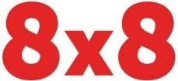
Outbound Caller ID Authorization Form

This document is to authorize 8x8 to use the above numbers as outbound caller line identification display; where will hold full responsibility of the use of the number(s).
Company Name

Customer Name:
Customer Address:
Number(s) to be displayed via 8x8:

Truth in Caller ID Act prohibits any person or entity from transmitting misleading or inaccurate caller ID information with the intent to defraud, cause harm, or wrongly obtain anything of value. Anyone who is illegally spoofing can face penalties of up to $10,000 for each violation.

In order to enable outbound caller ID Display for the above telephone number, 8x8 requires proof of ownership of the telephone numbers to be corroborated by a utility bill.

D Non 8x8 number(s) D Number(s) porting to 8x8
Name of Company Representative: Title:

Signature: Date:

